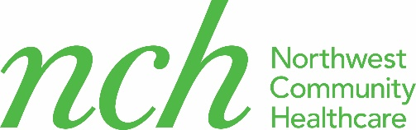

COVID 19 Dental treatment consent form

I, ______________________________, consent to receive dental treatment at NCH Mobile dental clinic during the COVID-19 pandemic. I understand and agree with the following statements:

- I understand that during this pandemic, my appointment and treatment process can be different than before.
- Dental treatment can create water spray (aerosols), which can cause COVID 19 to spread.
- This virus can survive up to 14 days and many patients who may appear healthy can spread this virus and can be highly contagious. Although mobile dental clinic is taking all precautions to prevent disease spread, I can still be at risk for catching virus in the dental clinic.
- If there is any in change in my treatment plan today, which requires care beyond the scope of what the Mobile Dental Clinic can provide, then I will be either rescheduled or referred to another dental office for further care.
- I will notify Mobile dental clinic if I or anyone in my family gets sick with COVID 19 in the coming 2 weeks.

Patient signature:_______________________

Date:_____________________

