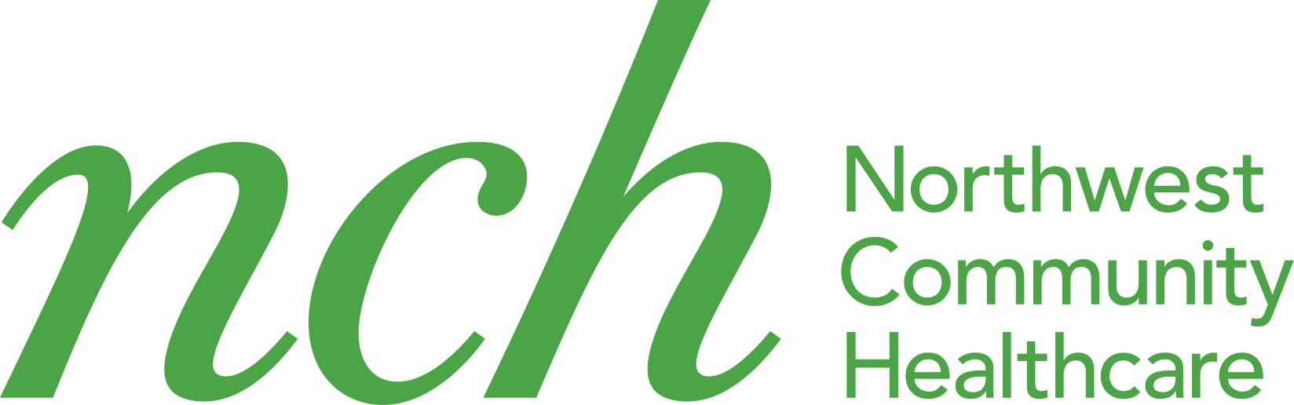
NCH

Initial Screening Form Requalification

Name: First: M.I.: Last:
Sex: M: F: Birth Date: Medicaid #:

Ethnicity: Hispanic/ Latino Not Hispanic/ Latino Declined

Race: American Indian/ Alaska Native Asian Black/ African American Caucasian/ White
Native Hawaiian/ Other Pacific Islander Multiracial Declined

Address: Apt.:

City: State: IL Zip:

Phone Number: Home :( ) Cell :( )

Receiving General Assistance? Yes: No: Do you have dental insurance? Yes: No:

PROVIDE INFO BELOW FOR OTHER FAMILY MEMBERS APPLYING TO USE MDC SERVICES

Spouses Name: Birth Date: Medicaid #:

Sex: M: F: Race: Ethnicity: (see categories above)

Name: Birthday: Gender: ID#:

Name: Birthday: Gender: ID#:

Name: Birthday: Gender: ID#:

**PLEASE SEND COPY OF MEDICAID CARD**

Do you need an interpreter? No: Yes: If yes, what language:

Do you require wheelchair access? Yes: No:

Do you have special needs? Yes: No: If Yes, explain:

Proof of address: Yes:No: Gross monthly income $:
I understand that my immigration/citizenship status in no way affects my ability to receive services from the Northwest Community Healthcare Mobile Dental Clinic.

Are you a U.S. citizen or legal permanent resident? Yes: No:

I certify that all statements stated above are true and correct to the best of my knowledge.

Signature: Date:

Authorizing Agent: Date:
3/2019

